Billy Hughes and the Russian war scare of 1885

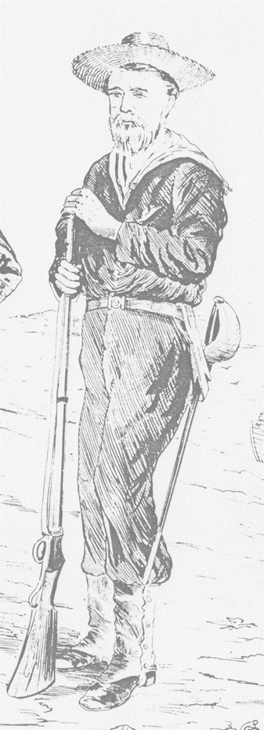
Author Frank C Browne in his 1946 biography of former Australian Prime Minister William Morris Hughes, recorded a brief story Hughes was apparently fond of re-telling. In this version Hughes recounted how he had spent time as a volunteer in the Queensland Defence Force during the Russian war scare of 1885, and was sent to guard the coal hulks on Thursday Island, or to scuttle them if the Russians arrived. Donald Horne in his biography of Hughes also mentions the event. Both stories appear to be based upon Hughes own accounts of his early days in Queensland. It is hard to say whether anyone believed him as he appears to have contradicted himself on a number of occasions when talking of his early life. Many stories have at their centre a kernel of truth and on examination this one leans heavily towards the realms of probability.
Hughes arrived in Brisbane around the end of 1884. Around the time he arrived there were plans afoot to form a naval volunteer company in Brisbane. The company, known locally as the Naval Brigade, commenced drill in late January 1885. Two 50-strong companies had been formed by March when they were formally gazetted. Sadly no muster rolls or petitions survive for those companies, and it is impossible to say if Billy Hughes had joined the ranks by then.
Military service was not unknown to Billy Hughes. While still a pupil-teacher at Westminster, before immigrating to Australia, Hughes was a member of one of the Volunteer Battalions of The Royal Fusiliers.
A contemporary illustration of a member of the Naval Brigade. Source: SLQ
War fever gripped the colony in April 1885 when it was feared Russia and Great Britain would go to war over Russian ambitions in Afghanistan. In addition to the mobilisation of some of the colony’s military forces, the Queensland Marine Defence Force, of which the Naval Brigade was part, was also allotted tasks.
Captain Wright RN, of the newly arrived Queensland gunboat Gayundah was given the task of commanding the Queensland Marine Defence Force. He inspected a full dress parade of 80 Naval Brigade men on 14 April, and called for volunteers to serve on the Gayundah, to join the troops at Lytton, and to protect the coaling hulks on Thursday Island. Twenty men and one officer were required for Thursday Island and full numbers were reached for that detachment. The following day they paraded at the Port Office and were issued with carbines and cutlasses. A delay in finding a vessel to steam to Thursday Island saw this detachment sent to Fort Lytton in the interim. Although the new Government steamer Advance was supposed to provide them passage, the detachment with Acting Sub-Lieutenant Cecil in command, did not leave Brisbane until 23 April aboard the ASN Company’s steamer Alexandra. There are no records of what the men actually did on Thursday Island, though there primary role was undoubtedly to deny the coal stores to the enemy. Once the danger of war passed the men were returned to Brisbane aboard the Advance. They were officially paid off on 1 July 1885.
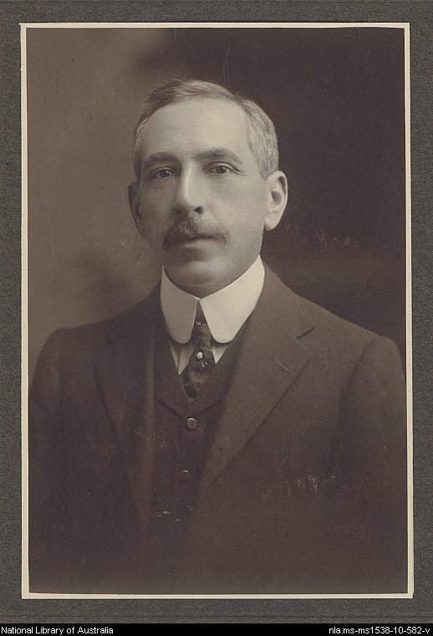
So was Billy Hughes a member of this detachment of the Naval Brigade? Only 22 men took part in that operation, and few others would even have known about it. Their service was certainly not a headline event. Although Billy Hughes sometimes said he served with the land defence force, and sometimes with the marine, it seems in all probability that he was a member of the Naval Brigade. How long he remained in the service is impossible to know. Such details as are known of his life in Queensland indicate he roamed the colony for a few years, before finally heading for Sydney c1889-90 as a crewman on a coastal steamer.
Portrait of Billy Hughes as a young man. Source: NLA
Billy Hughes went on to become a leading figure in Australian politics, and is particularly remembered for his controversial role as Prime Minister during the First World War.

CFSG(Q) examines the history of Queensland's naval and military forces (1860-1903)

